Name: Class:

Task 1
A small summer festival has a capacity for 1000 people at their venue. They allow groups of people in and once each group has been admitted they enter the number onto the computer. If the number of people in the venue is more than 1000 they won’t admit any more people.
The algorithm they use is as follows.

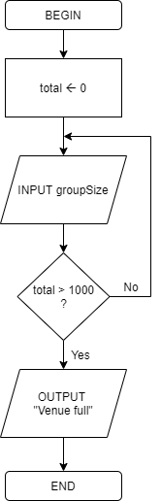

(a) Describe any problems with the algorithm.

(b) Draw a new flowchart to amend the algorithm and fix the problems you found.

Task 2
This task is based on the cycle race algorithm given in the presentation.
A cycle race has around 10 competitors. At the end of the race, each competitor’s time (in seconds) is entered to a program. The program automatically calculates the fastest time.

The pseudocode for the algorithm in the program is given below.
fastestTime 0
firstInput TRUE
moreTimes TRUE
WHILE moreTimes DO
INPUT time
IF time = -1
THEN
moreTimes FALSE
ELSE
IF firstInput
THEN
fastestTime time
firstInput FALSE
ELSE
IF time < fastestTime
THEN
fastestTime time
ENDIF
ENDIF
ENDIF
ENDWHILE
OUTPUT fastestTime

Draw a flowchart of the same algorithm.

Task 3
The following program written in pseudocode is for a joke generator that tells random jokes.
The user will be given the first part of the joke. Whatever they enter, the answer will then be displayed.
The function math.ceil(number) will round up number.
(a) Write a program in pseudocode for the joke generator. You may wish to use the following three jokes in the joke generator, or create your own.
(b) Write a program in a programming language for the joke generator.
Be aware that you may need to use a library to generate random numbers or round up a number.

